**Sprint 2 Plan**

Rapid Review

Developed by Jetskiz

Ends on 11/5/24

Revision #0, 10/23/24

Stand Up:

What have you done since the last stand-up?

What are you planning to do until the next stand-up?

Any Blockers (Something that needs to be done before you can keep progressing)

Ex: Database not added to the repo

#### **Goal**

* Add a new login feature that allows users to enter the site with their data saved. Also, we want to begin adding the multiple choice study feature and its background program aids.

#### **Tasks**

1. MH1. As a student, I want to practice answering multiple-choice questions created from my flashcards, so that I can study in an active way. (Not LLM tied-in) [13] (10.5hrs)
   1. Tasks:
      1. UI outline drawing - 30 minutes
      2. Interactive UI (React) - 6 hrs
      3. Adding unique data (front and back of cards) from set into the UI - 4 hrs
         1. having all questions appear at once (may want to limit the number of cards in a set or add a filter to the number of possible questions )
      4. Add spoof information as ‘incorrect’ answers (from the backs of other cards, or random info) - 1 hr
      5. Feedback (correct/incorrect responses listed) at the end of a multiple choice test - 3 hrs
2. MH2, As a new site visitor, I want to create an account so that I can create sets personal and viewable to me. [8] (5.25 hrs)
   1. Tasks:
      1. UI outline drawing - 15 minutes
      2. Make UI/page for account creation (react) - 1 hour
      3. Write the API, function code, and tests for the create account endpoint (backend) - 3 hour
      4. Integrate the create account endpoint (backend) with the front end - 1 hour
3. MH3. As a previous site visitor, I want to log in so that I can see the sets that I have created [5] (10 hrs)
   1. Tasks:
      1. Fix UI Admin thing - 2 hrs
      2. Write the API, function code, and tests for the login endpoint - 2 hour
      3. Update CRUD set endpoints with user (private) authentication - 3 hrs
         1. Create
         2. Read
         3. Update
         4. Delete
      4. Update CRUD card endpoints with user (private) authentication - 1 hrs
         1. Create
         2. Read
         3. Update
         4. Delete
      5. Update frontend http requests with authentication - 1 hrs
         1. HomePage
         2. CreateSetPage
      6. Integrate the login endpoint with front end - 1 hrs

(From Sprint 1)

1. MH4. As a student who uses various study platforms, I want to use flashcards from other places on this website, so I don’t waste time creating sets that already exist. [13] (12hrs)
   1. Tasks:
      1. Create interactive UI that dictates how to separate terms and definitions, as well as rows when importing - 8 hrs
         1. Create a text box to paste raw data into
         2. Create a field to specify term separator
         3. Create a field to separate rows
         4. Data cleansing so that special characters don’t break input **(potentially very important)**
      2. Break up the received flashcard info based off of the separators into a readable format for our system - 3 hrs
      3. Generate flashcards based off of received data (integrate frontend with backend import endpoint) - 1 hrs

If Time:

1. SH3. As a student, I want to practice answering free response questions created from my flashcards, so that I can study actively. (No LLM tie in) [5]
2. CH1. As a student, I want to mark specific cards in my set, so I know to focus my study effort on these cards. [3]

**Other Notes**

Spikes:

* 1. Prototyping LLM prompts
  2. Prototyping LLM output into the test generation
  3. Research how to deploy site

Infrastructure Tasks

* 1. Integrate lint and code coverage into frontend
  2. Increase code coverage of backend to better percentage
  3. Write unit tests for frontend
  4. Deploy site

Outside events:

* 1. Kev, Test 10/30
  2. Tiff GE midterm 10/28
  3. Serene/Zach/Tiff midterm 11/1
  4. serene unavailable 11/1-11/3
  5. tiff unavailable to get work done but can still attend meetings 10/24-10/25 (baskin day)

**TA Notes:**

Cloud service providers: heroku, vercel (more simple), gcp, aws(more sophisticated)

Deploy ASAP - test same thing, same environment

UI outline - comps, using FIGMA

Compare report with template - burn up chart in the report (sprint 2 exclusive)

#### **Team Roles**

* Serene Cheng: Developer
* Tiffany Guan: Developer
* Jiemas Rubio: Product Owner, Developer
* Zachary Venzor: Scrum Master, Developer
* Jianwen Wu: Developer

#### **Initial task assignment**

* Serene Cheng:
  + I’ll write unit tests for frontend (sprint 1 task)
  + merge fixes for typescript in frontend to sprint 2 dev branch
* Tiffany Guan:
  + UI outline drawings
  + MH3 + help with MH2 if needed
* Jiemas Rubio:
  + Infrastructure stuff (backend unit tests and backend code coverage)
* Zachary Venzor:
  + MH2 - will work on MH3 after finishing
* Jianwen Wu:
  + help serene merge git
  + Take a stab at fixing the lint frontend

#### **Initial Burnup Chart: Zach will do this**

#### **Initial Scrum Board: Jira**

#### **Scrum Times**

* Sun/Wed/Fri @ 9:45 pm
* Thurs TA meeting @ 4pm

#### **Check-ins**

10/23/24 - Wednesday: a - will do, b - have done

1. Jiemas
   1. Infrastructure - backend unit tests, backend code coverage
   2. Did nothing since last meeting
2. Tiff
   1. UI outline drawings, MH3 crud tasks, learning express.js
   2. Did nothing since last meeting
3. Serene
   1. Finishing tasks from last sprint
   2. Fixed typescript type errors, need conversion to constant types (needs testing and merge), trying (WIP) to fix the loading thing by delaying the fetch
4. Zach
   1. UI outline drawing MH2, enable functionality using react
   2. Got promoted, prompt engineering request to LLMs
5. [Jianwen Wu](mailto:jwu287@ucsc.edu)
   1. Help Serene merge git , Take a stab at fixing the lint frontend
   2. Did nothing since the last sprint
6. ‘

10/24/24 - Thursday: a - have done, b - will do, c - blockers

1. Jiemas
   1. Infrastructure, updated/added unit tests backend.
   2. Not sure
   3. Waiting for Scrum Board - will claim task
2. Tiffany
   1. New Sprint
   2. Creating UI diagrams for generating test features / login.
   3. No blockers, scrum board
3. Serene
   1. New sprint
   2. Merging / finishing resolving typescript errors
   3. No blockers
4. Zach
   1. New sprint
   2. UI outline drawings MH2
   3. Scrum board
5. Jianwen Wu
   1. New sprint
   2. Setting up lint on front end, pick a new task from scum board
   3. No blockers

10/25/24 - Friday: a - have done, b - will do, c - blockers

1. Jiemas
   1. Deployed front end and back end. Backend package.json completely new.
   2. Endpoints for create account and login.
   3. none
2. Tiffany
   1. Finished UI diagram for generating multiple test.
   2. Draw other UI diagrams. Pick a MH3 Jira task.
   3. none
3. Serene
   1. WIP, debugging.
   2. Merging / finishing resolving typescript errors. Will assign Jira task
   3. none
4. Zach
   1. Jira board
   2. UI outline drawings MH2
   3. none
5. Jianwen Wu
   1. Out sick

10/27/24 - Sunday: a - have done, b - will do, c - blockers

1. Jiemas
   1. MH3 - task 2: login endpoint, MH3 - task 2: create endpoint
   2. MH3 - task 3: CRUD endpoints, MH3 task 5, MH3 task 6
   3. MH3 - task 4
2. Tiffany
   1. Created UI drawing for multiple choice test
   2. MH3 - task 4
   3. None
3. Serene
   1. Pushed fixes, needs merge
   2. Writing UI tests
   3. None
4. Zach
   1. None
   2. MH2 Outline
   3. Blockers
5. Jianwen Wu
6. Set up Lint for frontend
7. Will grab another test
8. UI page for import parsing

NOTES: Start deleting branches after they are merged. TSR3 & RAC2 Due Tuesday.

10/30/24 - Wednesday: a - have done, b - will do, c- blockers (12hr)

1. Jianwen (4hr)
   1. MH4 - Task 47 & 48 (4 hrs), Pushed frontend lint
   2. Finish up UI for MH4 and Link up the backend
   3. None

16. Jiemas (7hr)

1. MH3 T3 (3hrs), MH3 T6 (1hr), MH2 T2 (1hr), MH2 T4(1hr), MH3 T5 (1hr)
2. Review new dev branch, update deployments, review import backend code, merge authenticated frontend to dev branch
3. None

17. Tiffany (1hr)

1. MH3 - task 4: update card CRUD endpoints with user authentication (1hr)
2. Maybe choose a frontend task but I have a midterm to study for on Friday
3. No blockers, just need to start learning about frontend stuff

18. Serene (0hr)

1. what i did: merged login unit test and fixed broken settings in login.
2. i will: make more unit tests and possibly start on frontend for mh1 (t2) if unit testing goes great.
3. no blockers.

10/31/24 - Thursday: a - have done, b - will do, c - blockers

1. Jiemas (2hr)
   1. MH3 - task 2: login endpoint (2hr), MH3 - task 2: create endpoint
   2. Helping with back
   3. MH3 - task 4
2. Tiffany (0hr)
   1. MH3 - taks 4, passed unit (NA)
   2. Assign front end task
   3. None
3. Serene (0hr)
   1. Login unit tests
   2. Login unit tests
   3. None
4. Zach (0hr)
   1. None
   2. MH2 Outline
   3. Blockers
5. Jianwen Wu (0hr)
6. Reviewed MH3 w/ Jiemas (merge), lint for frontend, task 47,48 MH4, (NA)
7. Completing MH4 (task 13,29)
8. None

NOTES: selenium code tests(to try, 1-2 tests), SOLID principles: review folder structure for TA feedback, front-end component hierarchy, make sure that the front-end is modular (reusable) which is one of the main ideas of react, investigate how we are maintaining our state (redux), Atomic principles for React, Material UI principles,

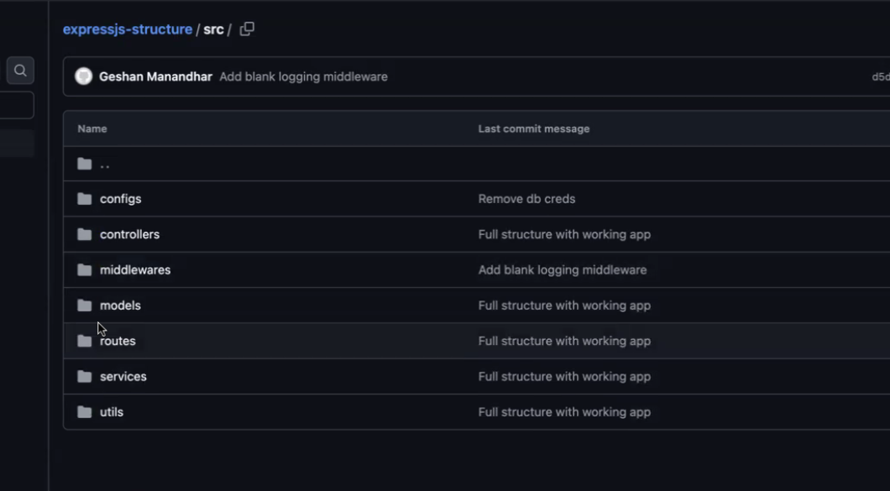

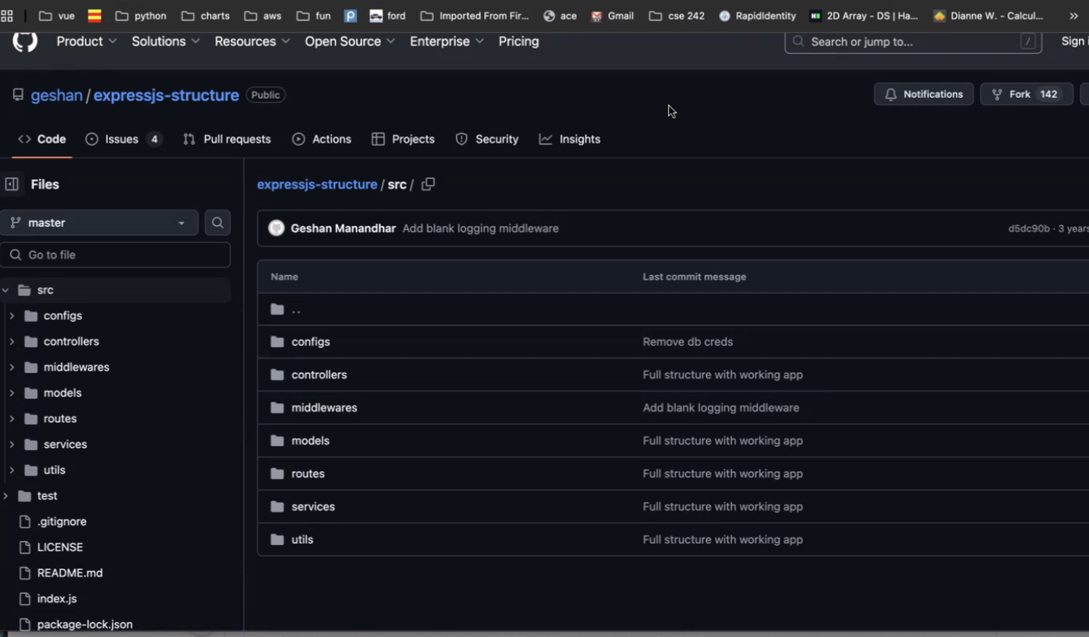

Understand backend structure for node.js engineering model

11/01/24 - Friday: a - have done, b - will do, c - blockers

1. Jiemas (0hr)
   1. Working on front end tests. Testing backend.
   2. Whatever is needed.
   3. None
2. Tiffany (0hr)
   1. None
   2. Assign front end task
   3. None
3. Serene (0hr)
   1. Login unit tests
   2. Login unit tests
   3. None
4. Zach (11hr)
   1. MH1 tasks 2 (6hr),3 (4hr),4 (1hr)
   2. MH1 task 5, UI style improvements
   3. None
5. Jianwen Wu (0hr)
6. Lint for frontend
7. Another task (if available)
8. None

11/03/24 - Sunday: a - have done, b - will do, c - blockers

1. Jiemas
   1. Merged debugging to dev, helped Kev w/ lint frontend infrastructure
   2. Help finalize MH1 w/ Zach
   3. None
2. Tiffany
   1. Nothing task related (apparently MH1 T1 was done in past) (.5hr)
   2. Learn frontend files
   3. None
3. Serene
   1. Login unit tests
   2. Login unit tests
   3. None
4. Zach (3hr)
   1. MH1 tasks 2,3,4
   2. MH1 task 5, UI style improvements (3hr)
   3. None
5. Jianwen Wu
6. Lint for frontend (finished)
7. Another task (if available)
8. None